Data Structure and Algorithm 2

Hamza Alhassan

Git repository: https://github.com/zayd197/dsa2-exercises

1.Maze Solver

The program loads the maze image, converts it into a 21 x 21 grid, asks the user for an approach, solves the maze and shows every square it visited.
I read the 210 x 210 pixel image with plt.imread, so each square is 10 x 10 pixels. The middle pixel of each square decides wall (1) or path (0), and the grid is stored as a list of lists, maze[row][col]. It is printed with ## for walls and two spaces for paths. The entrance is at (0, 9) and the exit at (20, 11)
The program asks the user to type backtracking or las vegas. A while loop keeps asking until the answer is valid
Las Vegas approach
At each step the program lists every neighbouring square (up, down, left, right) that is inside the grid and is not a wall. It picks one at random with random.choice. It does not step straight back to the square it just came from unless that is the only option, which happens at a dead end.
The run ends when the exit is reached (successful) or after 200 steps (unsuccessful).
Backtracking approach
Directions are tried in the order down, right, left, up, because the exit is at the bottom and slightly right of the entrance. The current route is a list used as a stack: each new square is added with append, and at a dead end path.pop() steps back one square to try the remaining directions. A visited list stops squares being explored twice.

Visualising the visited squares
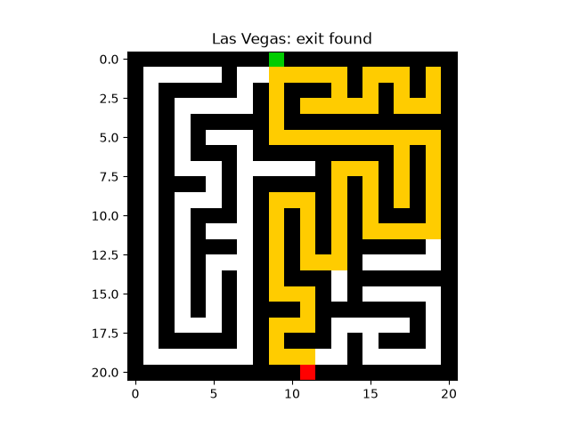Las Vegas successful

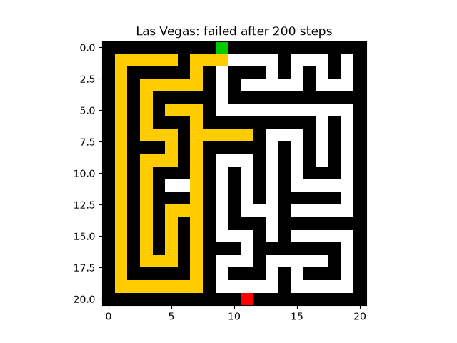Las Vegas unsucessful

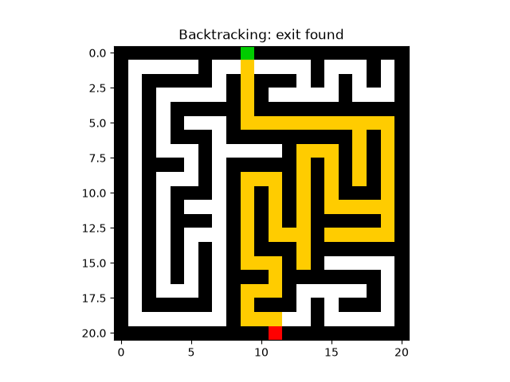backtracking successful

Some Errors I ran into
Error 1.
What went wrong: I was trying to print the maze to terminal. The maze printed as a long shaped instead of the 21 by 21 grid.
Fix: my print(line) was inside the column loop, so it ran 21 times per row instead of just once. This needed to fixed else every function depending on this output will be wrong. Identing properly fixed this bug.

Screenshot Error 1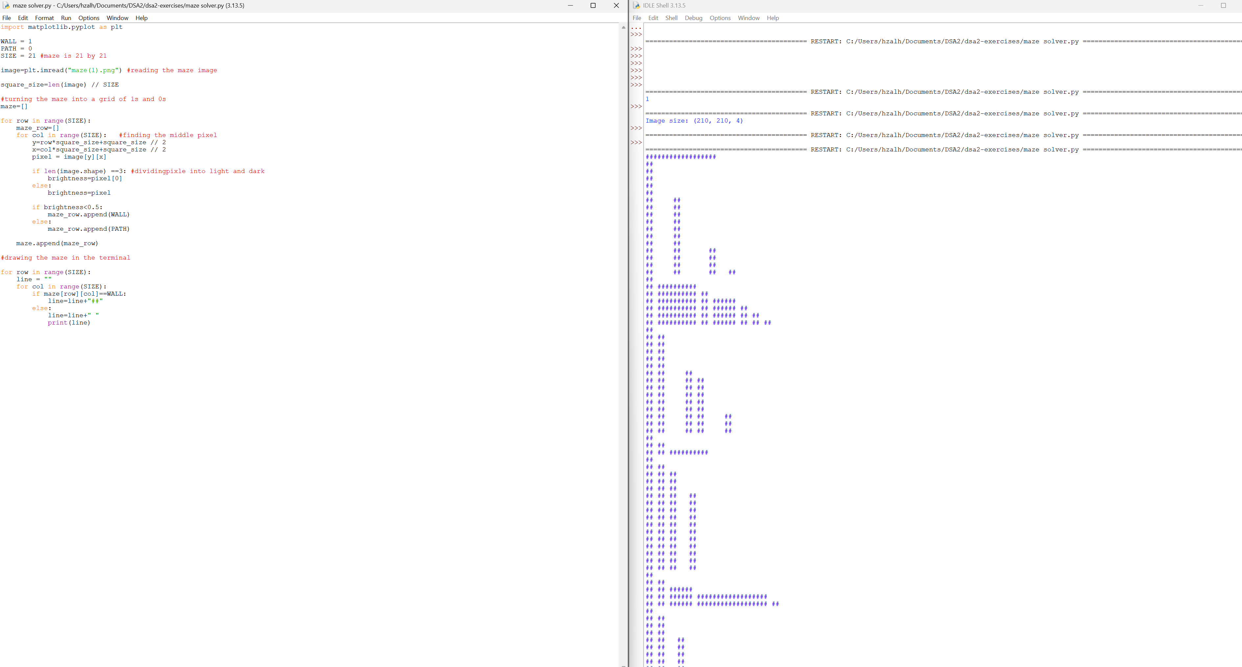

Error 2
What went wrong: after fixing the first error and running the code again. The below exhibit is seen. The corridors are not aligned
Fix: the path string was one space but the wall string was two characters so the squares had different widths. I changed the path to two spaces and they became squares again.

Screenshot Error2
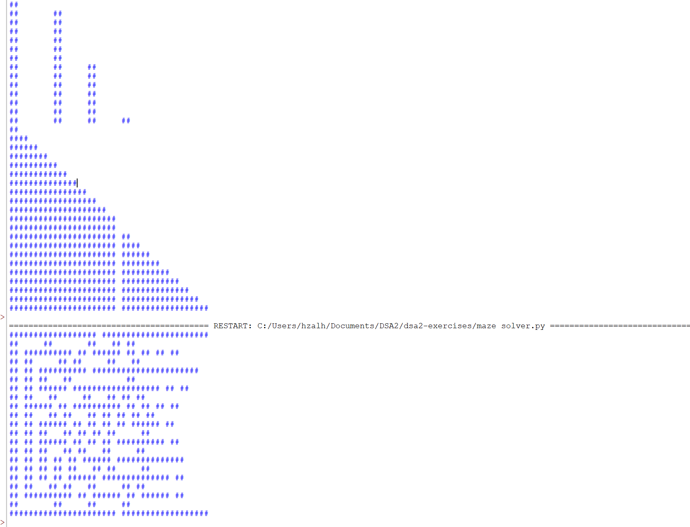

Fixed code
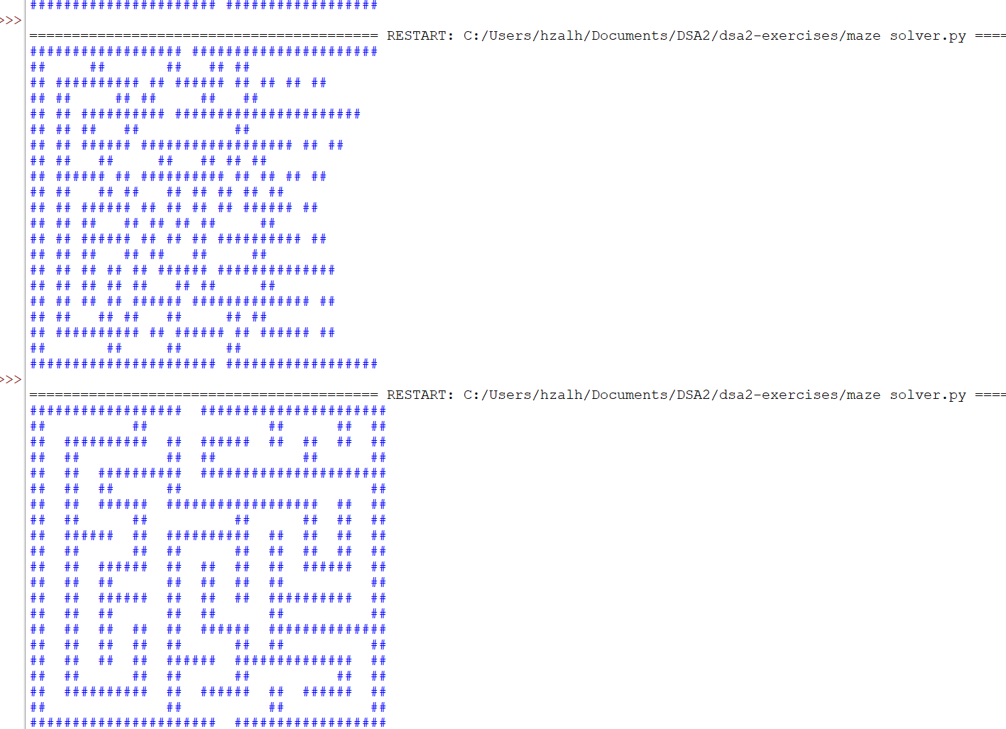

3rd bug
What went wrong : Las vegas approach never found the exit after 1000 runs. Increasing this to 10000 runs didn’t make a difference.
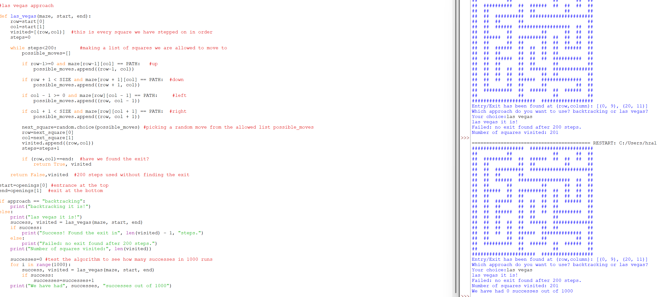

Fix: it seem when picking random direction from the allowed list, we often went backwards to the square we were just at. I have added a two lines that say don’t go straight back unless it is the only way. It has increased our success rate.

Las vegas run
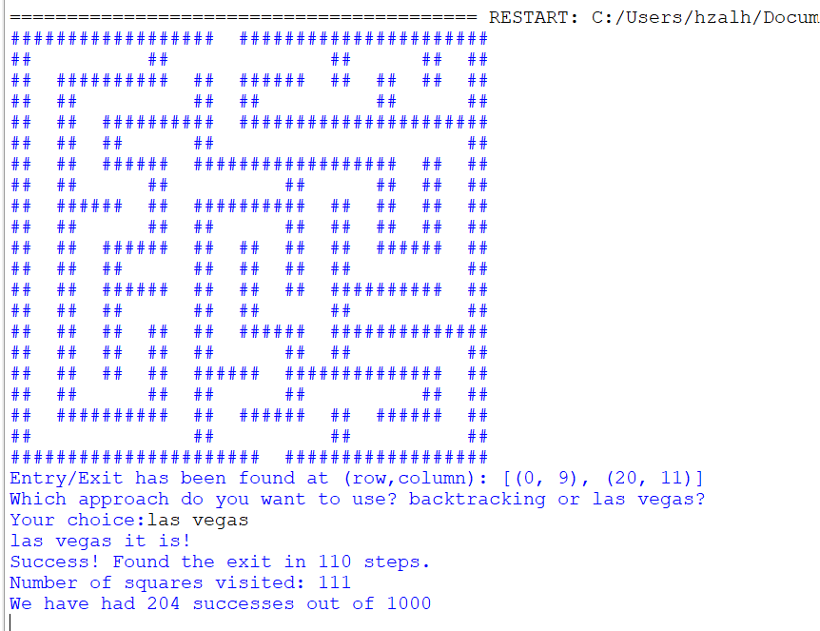

Backtracking run
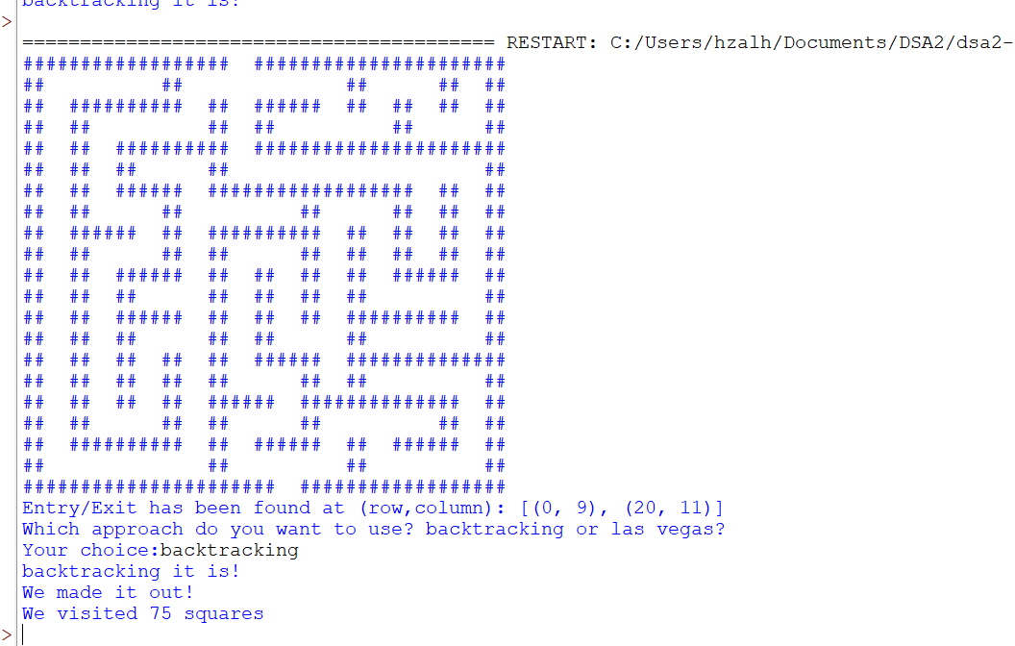

Completed Maze solver
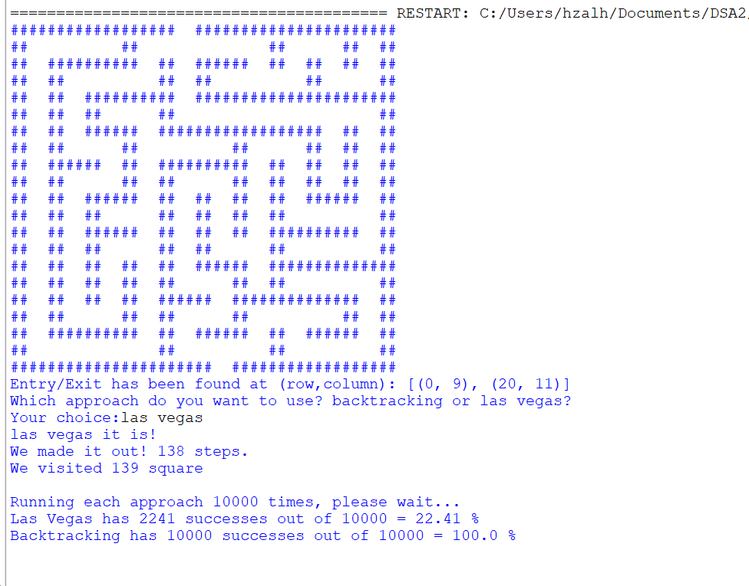

Code:
import matplotlib.pyplot as plt
import random

WALL = 1
PATH = 0
SIZE = 21 #maze is 21 by 21

image=plt.imread("maze(1).png") #reading the maze image

square_size=len(image) // SIZE
#turning the maze into a grid of 1s and 0s
maze=[]

for row in range(SIZE):
maze_row=[]
for col in range(SIZE): #finding the middle pixel
y=row*square_size+square_size // 2
x=col*square_size+square_size // 2
pixel = image[y][x]

if len(image.shape) ==3: #dividingpixle into light and dark
brightness=pixel[0]
else:
brightness=pixel

if brightness<0.5:
maze_row.append(WALL)
else:
maze_row.append(PATH)

maze.append(maze_row)

#drawing the maze in the terminal

for row in range(SIZE):
line = ""
for col in range(SIZE):
if maze[row][col]==WALL:
line=line+"##"
else:
line=line+" "
print(line)

#finding the entrance and exit of the maze. They will be the path squares on the outside edge of the maze.
openings=[]
for row in range(SIZE):
for col in range(SIZE):
if row == 0 or col == 0 or row == SIZE -1 or col == SIZE -1:
if maze[row][col] == PATH:
openings.append((row,col))
print("Entry/Exit has been found at (row,column):",openings)

#Now we are going to ask the user which approach he will use

approach=""

while approach != "backtracking" and approach !="las vegas":
print("Which approach do you want to use? backtracking or las vegas?")
approach=input("Your choice:")

if approach != "backtracking" and approach != "las vegas":
print("Please choose backtracking or las vegas")

#las vegas approach

def las_vegas(maze, start, end):
row=start[0]
col=start[1]
previous=None #the square we just came from
visited=[(row,col)] #this is every square we have stepped on in order
steps=0

while steps<200: #making a list of squares we are allowed to move to
possible_moves=[]

if row-1>=0 and maze[row-1][col] == PATH: #up
possible_moves.append((row-1, col))

if row + 1 < SIZE and maze[row + 1][col] == PATH: #down
possible_moves.append((row + 1, col))

if col - 1 >= 0 and maze[row][col - 1] == PATH: #left
possible_moves.append((row, col - 1))

if col + 1 < SIZE and maze[row][col + 1] == PATH: #right
possible_moves.append((row, col + 1))

if len(possible_moves)>1 and previous in possible_moves: #this says dont go straight back unless it is the only way
possible_moves.remove(previous)

next_square=random.choice(possible_moves) #picking a random move from the allowed list possible_moves
previous=(row,col)
row=next_square[0]
col=next_square[1]
visited.append((row,col))
steps=steps+1

if (row,col)==end: #have we found the exit?
return True, visited

return False,visited #200 steps used without finding the exit

#backtracking approach

def backtracking(maze, start, end):
path=[start] #the route we are on right now (works like a stack)
visited=[start] #every square we have ever stepped on

while len(path) > 0:
row=path[-1][0] #the last square in the path is where we are now
col=path[-1][1]

if (row,col) == end: #have we found the exit?
return True, visited

moved=False

if moved == False and row+1 < SIZE and maze[row+1][col] == PATH and (row+1,col) not in visited: #going down
path.append((row+1,col))
visited.append((row+1,col))
moved=True

if moved == False and col+1 < SIZE and maze[row][col+1] == PATH and (row,col+1) not in visited: #going right
path.append((row,col+1))
visited.append((row,col+1))
moved=True

if moved == False and col-1 >= 0 and maze[row][col-1] == PATH and (row,col-1) not in visited: #going left
path.append((row,col-1))
visited.append((row,col-1))
moved=True

if moved == False and row-1 >= 0 and maze[row-1][col] == PATH and (row-1,col) not in visited: #going up
path.append((row-1,col))
visited.append((row-1,col))
moved=True

#dead end: no new square to move to, so go back one square
if moved == False:
path.pop()

return False, visited #path is empty: we went all the way back to the start

#drawing the maze with the visited squares coloured in

def show_visited(maze, visited, start, end, title):
picture=[]
for row in range(SIZE):
picture_row=[]
for col in range(SIZE):
if (row,col) == start:
picture_row.append([0, 0.8, 0]) #green = entrance
elif (row,col) == end:
picture_row.append([1, 0, 0]) #red = exit
elif (row,col) in visited:
picture_row.append([1, 0.8, 0]) #yellow = visited
elif maze[row][col] == WALL:
picture_row.append([0, 0, 0]) #black = wall
else:
picture_row.append([1, 1, 1]) #white = not visited
picture.append(picture_row)

plt.imshow(picture)
plt.title(title)
plt.savefig("visited.png") #saves a copy of the picture for the report
plt.show()

#running the approach the user chose

start=openings[0] #entrance at the top
end=openings[1] #exit at the bottom

if approach == "backtracking":
print("backtracking it is!")
success, visited = backtracking(maze, start, end)
if success:
print("We made it out!")
show_visited(maze, visited, start, end, "Backtracking: exit found")
else:
print("We got lost.")
show_visited(maze, visited, start, end, "Backtracking: no route found")
print("We visited", len(visited),"squares")

else:
print("las vegas it is!")
success, visited = las_vegas(maze, start, end)
if success:
print("We made it out!", len(visited) - 1, "steps.")
show_visited(maze, visited, start, end, "Las Vegas: exit found")
else:
print("We got lost after 200 steps")
show_visited(maze, visited, start, end, "Las Vegas: failed after 200 steps")
print("We visited", len(visited), "square")
#success rate of each approach after 10000 runs
RUNS=10000
las_vegas_successes=0
backtracking_successes=0

print()
print("Running each approach", RUNS, "times, please wait...")

for i in range(RUNS):
success, visited = las_vegas(maze, start, end)
if success:
las_vegas_successes=las_vegas_successes+1

success, visited = backtracking(maze, start, end)
if success:
backtracking_successes=backtracking_successes+1

las_vegas_rate=las_vegas_successes/RUNS*100
backtracking_rate=backtracking_successes/RUNS*100

print("Las Vegas has", las_vegas_successes, "successes out of", RUNS, "=", round(las_vegas_rate, 2), "%")
print("Backtracking has", backtracking_successes, "successes out of", RUNS, "=", round(backtracking_rate, 2), "%")

2.MyMinimumSpanningTree
I implemented Kruskal’salgorithm in MyMinimumSpanningTree, which takes a network graph and return its minimum spanning tree as a network graph.

How the code works
- Lisitng and sorting edges. Each edge is stored as a tuple (weight,node1,node2). The tuples are sorted by weight using edges.sort()
- A new graph is then created with every node from the original but no edges.
- For each edge nx.has_path(nst,node1,node2) checks if the two nodes are already connected. If they are, the edge is skipped and if not it is added with its weight.
- Every decision is printed on the console showing the MST being built step by step.
- I used draw-graph which uses nx.draw and nx.draw_networkx_edge_labels to draw the graphs.

See graphs and console output below

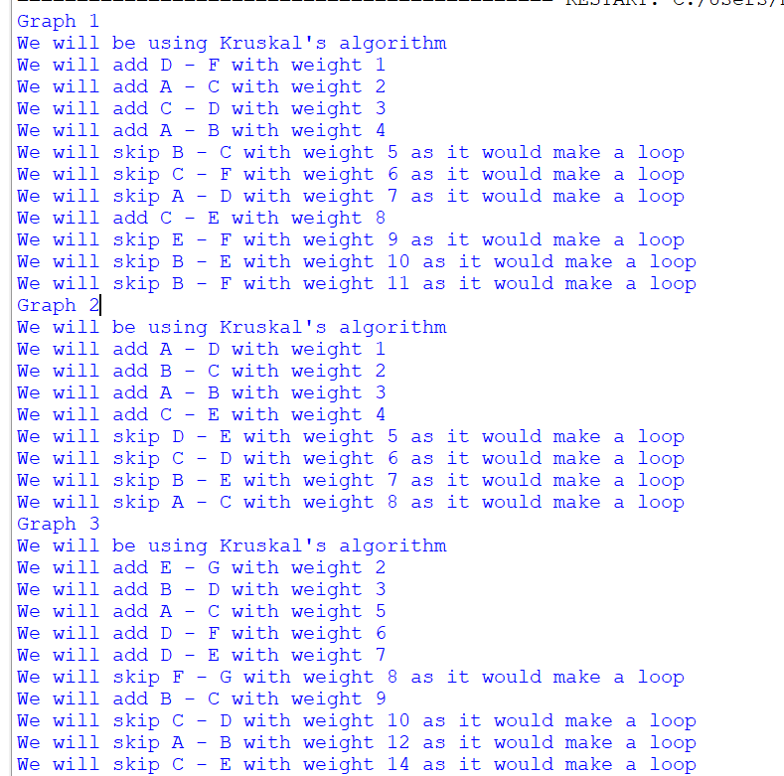
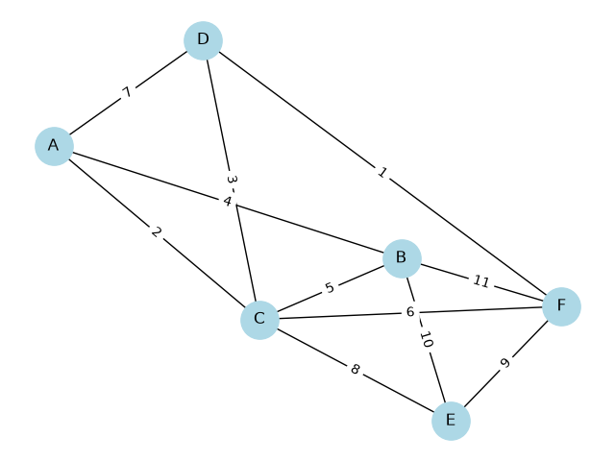Graph1
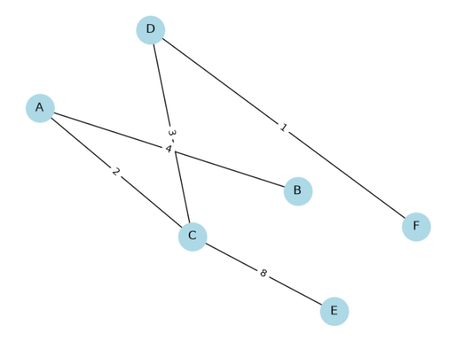Graph1 MST
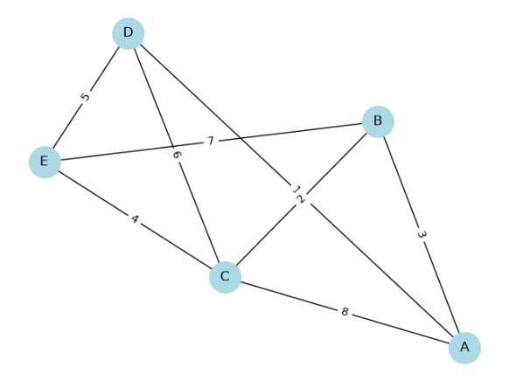Graph2
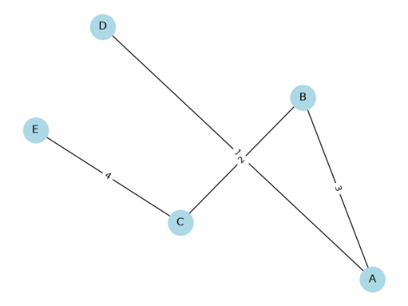Graph2 MST

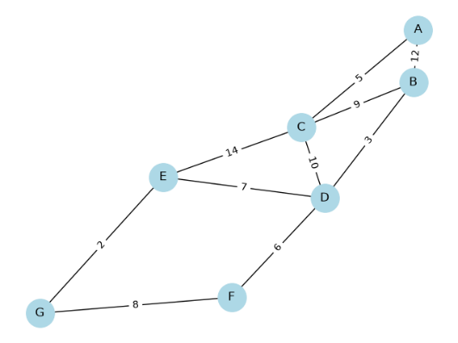Graph3
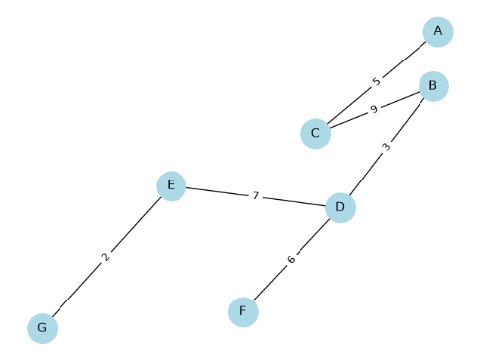Graph3 MST

Code:
import networkx as nx
import matplotlib.pyplot as plt
#Kruskal's algorithm
def MyMinimumSpanningTree(Graph) -> nx.Graph:
print("We will be using Kruskal's algorithm")
#making a list of all the edges as weight, node1 and node2
edges=[]
for node1,node2,data in Graph.edges(data=True):
edges.append((data["weight"],node1,node2))

edges.sort() #this sorts the edges from in terms of weight, smallest to biggest

mst=nx.Graph() #starting the MST with all the nodes but no edges
mst.add_nodes_from(Graph.nodes())

for edge in edges: #looking at all the edges starting with the smallest one
weight=edge[0] #each tuple is split into three named variables edge[0],edge[1] and edge[2]
node1=edge[1]
node2=edge[2]
if nx.has_path(mst,node1,node2): #this says in hte mst built so far, can i get from node1 to node2? (Kruskal's rule)
print("We will skip",node1,"-",node2,"with weight",weight, "as it would make a loop") #yes, so adding this will create a loop. we will skip it.
else:
mst.add_edge(node1,node2,weight=weight)#they are not connected to this edge will be added to MST with its weight.
print("We will add",node1,"-",node2,"with weight", weight)
return mst
def draw_graph(Graph, positions, title):
nx.draw(Graph, positions,with_labels=True, node_color="lightblue",node_size=800) #draws the functions and edges, with_labels=true writes the letters on the nodes
nx.draw_networkx_edge_labels(Graph, positions, edge_labels=nx.get_edge_attributes(Graph, "weight"))#writes each edge weights on its line
plt.title(title)#adds a heading
plt.show()#opens it in a window

#drawing graph1 with 6 nodes and 11 edges

graph1=nx.Graph()
graph1.add_edge("A", "B", weight=4)
graph1.add_edge("A", "C", weight=2)
graph1.add_edge("A", "D", weight=7)
graph1.add_edge("B", "C", weight=5)
graph1.add_edge("B", "E", weight=10)
graph1.add_edge("C", "D", weight=3)
graph1.add_edge("C", "E", weight=8)
graph1.add_edge("C", "F", weight=6)
graph1.add_edge("D", "F", weight=1)
graph1.add_edge("E", "F", weight=9)
graph1.add_edge("B", "F", weight=11)

print("Graph 1")
positions1=nx.spring_layout(graph1, seed=1)
draw_graph(graph1, positions1, "Graph 1")
mst1=MyMinimumSpanningTree(graph1)
draw_graph(mst1, positions1, "Graph 1 MST")

#drawing graph2 with 5 nodes and 8 edges

graph2=nx.Graph()
graph2.add_edge("A", "B", weight=3)
graph2.add_edge("A", "C", weight=8)
graph2.add_edge("A", "D", weight=1)
graph2.add_edge("B", "C", weight=2)
graph2.add_edge("B", "E", weight=7)
graph2.add_edge("C", "D", weight=6)
graph2.add_edge("C", "E", weight=4)
#
print("Graph 2")
positions2=nx.spring_layout(graph2, seed=2)
draw_graph(graph2, positions2, "Graph 2")
mst2=MyMinimumSpanningTree(graph2)
draw_graph(mst2, positions2, "Graph 2 MST")

#drawing graph3 with 7 nodes and 10 edges

graph3=nx.Graph()
graph3.add_edge("A", "B", weight=12)
graph3.add_edge("A", "C", weight=5)
graph3.add_edge("B", "C", weight=9)
graph3.add_edge("B", "D", weight=3)
graph3.add_edge("C", "E", weight=14)
graph3.add_edge("D", "E", weight=7)
graph3.add_edge("D", "F", weight=6)
graph3.add_edge("E", "G", weight=2)
graph3.add_edge("F", "G", weight=8)
graph3.add_edge("C", "D", weight=10)

print("Graph 3")
positions3=nx.spring_layout(graph3, seed=3)
draw_graph(graph3, positions3, "Graph 3")
mst3=MyMinimumSpanningTree(graph3)
draw_graph(mst3, positions3, "Graph 3 MST")

3. Recursion
Follow_instructions uses recursion to follow the colour rules through the list and returns the indexes that were visited. For the example, it retuen[0,4,5]
Follow_instructions calls a helper, visit(instructions,i) starting at index 0 because the recursion needs to know the current index.
Base Case is whenever I is past the end of the list return[]. The next index green is i+1, red is 2*i+1, and blue is the element after the next “blue”.
Recursive case: return [i] + visit(instructions, next index).
Console results
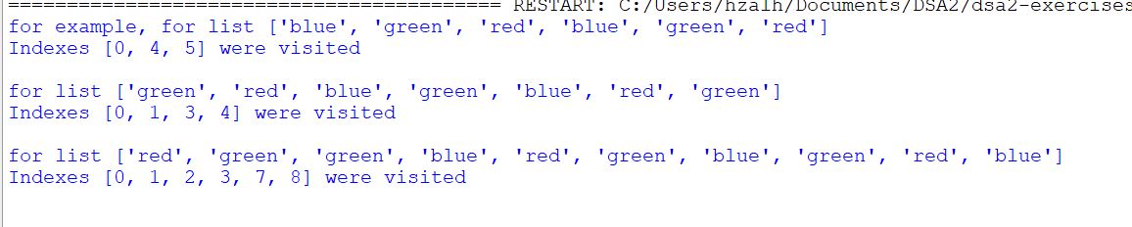
Flow chart
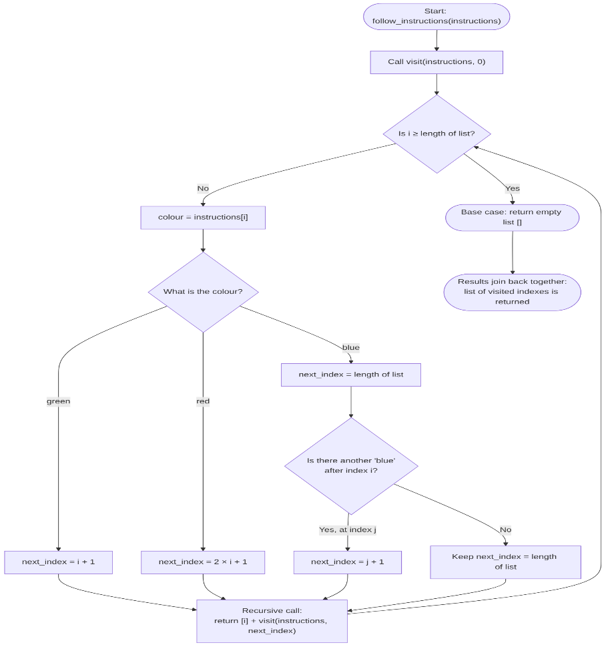

Code:
import random

#this function does recursion. It visits i, then call itself for the next index
def visit(instructions, i):
#base case: if the index is past the end of the list we stop and give back an empty list
if i >= len(instructions):
return []
colour=instructions[i]
if colour == "green":
next_index=i+1 #if green go to the next element
elif colour == "red":
next_index=2*i+1 #if red go to index 2*i + 1
else:
#blue: find the next "blue" after this one, then go to the element after it
next_index=len(instructions) #if there is no other blue, we will stop
for j in range(i+1, len(instructions)):
if instructions[j] == "blue":
next_index=j+1
break
#recursive case: this index, followed by every index visited from the next one
return [i] + visit(instructions, next_index)

def follow_instructions(instructions: list[str])-> list[int]: #takes the list and starts recursion at index 0
return visit(instructions,0)
#first test, answer should be [0,4,5]
list1=["blue","green","red","blue","green","red"]
print("for example, for list",list1)
print("Indexes", follow_instructions(list1),"were visited")
print()
list2=["green","red","blue","green","blue","red","green"] #second test, the answer should be [0,1,3,4]
print("for list",list2)
print("Indexes", follow_instructions(list2),"were visited")
print()

list3=["red","green","green","blue","red","green","blue","green","red","blue"]#third test, the answer should be [0,1,2,3,7,8]
print("for list",list3)
print("Indexes", follow_instructions(list3),"were visited")
print()

4. Needleman-Wunsch
Strings ATTACACG and CACAGAGT using the scoring below
Match = +1
Mismatch = -1
Gap = -1

The first row and column are 0,-1,-2,-3,-4,-5,-6,-7 and -8 because they are all gaps.starting from the top left, every other cell just takes the highest of three values from the following
Diagonal :the top left cell +1 if the letters or -1 if they do not match
Top: the cell above -1(a gap)
Left: the cell to the left -1(a gap)
For example, for the first letter A in both strings, the letters match
Diagonal: -1+1=0
Top:-2-1=-3
Left: -1-1=-2
The cell is 0 because 0 is the highest.
 | ε | C | A | C | A | G | A | G | T
ε | 0 | -1 | -2 | -3 | -4 | -5 | -6 | -7 | -8
A | -1 | -1 | 0 | -1 | -2 | -3 | -4 | -5 | -6
T | -2 | -2 | -1 | -1 | -2 | -3 | -4 | -5 | -4
T | -3 | -3 | -2 | -2 | -2 | -3 | -4 | -5 | -4
A | -4 | -4 | -2 | -3 | -1 | -2 | -2 | -3 | -4
C | -5 | -3 | -3 | -1 | -2 | -2 | -3 | -3 | -4
A | -6 | -4 | -2 | -2 | 0 | -1 | -1 | -2 | -3
C | -7 | -5 | -3 | -1 | -1 | -1 | -2 | -2 | -3
G | -8 | -6 | -4 | -2 | -2 | 0 | -1 | -1 | -2

The optimal score is -2.

Traceback
Starting from the bottom-right cell, I moved to the neighbor that producd each value, choosing diagonal when there was a tie. A diagonal step joins two letters, an up step step puts a gap in CACAGAGT and a left step puts a gap in ATTACACG.

- Left, -/T
- Choose diagonal, G and G match
- Choose Diagonal, C and A don’t match
- Left, -/G
- Choose Diagonal, A and A match
- Choose Diagonal, C and C match
- Choose Diagonal, A and A match
- Choose diagonal, T and C don’t match
- UP, T/-
- UP,A/-, we have now reached the top-left cell.

String Alignment
We have 4 matches(+4), 2 mismatches(-2) and 4 gaps(-4)
4-2-4=-2
ATTACA-CG-
--CACAGAGT

If the substitution penalty is bigger than the gap penalty, the optimal alignment changes because the algorithm prefers to add gaps than accept mismatches. With a mismatch of -3 and a gap of -1, the new alignment will be :
-A-TTA-CACG-
CAC--AG-A-GT

5. Cat swarm optimization and Grey Wolf optimizer

Both papers compare their algorithm with Particle Swarm optimization(PSO) and both outperform it.
- Behaviors modelled by each paper
- Cat Swarm Optimization (Chu, Tsai and Pan, 2006)
Seeking mode: a cat resting but alert. It considers several nearby positions and moves to one, with better positions more likely to be chosen.
Tracing mode: a cat chasing a target. It moves towards the best cat found so far.

A small mixture ratio (MR) puts most cats in seeking mode because in real life cats spend most of their time resting.

ii. Grey wolf Optimizer (Mirjalili, Mirjalili and Lewis, 2014)
Social Hierarchy: the three best solutions are the alpha, beta and delta wolves while the rest are the omega wolves that follow them.
Encircling prey: wolves position themselves around the prey
Hunting: wolves move using positions of the alpha, beta and delta who know where the prey is(exploitation).
Attacking prey: wolves close in on the prey as the run goes on.
Searching the prey: wolves move apart to explore new areas covering more ground(exploration).

- Similarities with PSO
Both algorithms improve on PSO. GWO’s evidence is stronger with 29 functions and averages over 30 runs while CSO only shows one graph. The papers used different tests, so each can only be compared with PSO, not directly with each other.

Sources
- Chu, S.C., Tsai, P.W. and Pan, J.S. (2006). Cat Swarm Optimization. PRICAI 2006, LNAI 4099, pp. 854–858.
- Mirjalili, S., Mirjalili, S.M. and Lewis, A. (2014). Grey Wolf Optimizer. Advances in Engineering Software, 69, pp. 46–61.

